WEATHER ANALYSIS CAPSTONE PROJECT

HERE THE REGIONAL DIVERSITY AND FLUCTUATION OF DIFFERENT PARAMETERS CAN BE FOUND OUT.

LOCATION ANALYSIS

THE VARIATION OF HUMIDITY AND WEATHER TYPES CAN BE ANALYSED AND COMPARED WITH OTHER PARAMETERS.

HUMIDITY AND WEATHER ANALYSIS

THE TEMERATURE CHANGE CAN BE ANALYSED AND COMPARED WITH OTHER PARAMETERS.

TEMPERATURE ANALYSIS

THE WIND DIRECTION AND SPEED CAN BE ANALYSED AND COMPARED WITH OTHER PARAMETERS

WIND DIRECTION AND SPEED ANALYSIS

GLOBAL COMPARISION

WE CAN COMPARE GLOBAL ENVIRONMENTAL PARAMETERS WITH OTHER DEVELOPMENTAL KEY INDICATORS.

|  |  |  |  |  |  |  |  |  |  |  |
| --- | --- | --- | --- | --- | --- | --- | --- | --- | --- | --- |
| *1.Are there any countries with cities located at extreme latitudes, and how might this impact their climate?* | | | | | | | | | | |
|  |  |  |  |  |  |  |  |  |  |  |
|  | select * from city_attributes1 where Latitude>40; | | | | |  |  |  |  |  |
|  |  |  |  |  |  |  |  |  |  |  |

|  |  |  |  |  |  |  |  |  |  |
| --- | --- | --- | --- | --- | --- | --- | --- | --- | --- |
|  |  |  |  |  |  |  |  |  |  |
|  | City | Country | Latitude | Longitude | temp | humidity | pressure | windspeed | |
|  | Boston | United States | 42.35843 | -71.0598 | 283.7798 | 77.3753 | 1019.861 | 3.380889 |  |
|  | Chicago | United States | 41.85003 | -87.65 | 283.3506 | 74.43492 | 1018.896 | 3.759326 |  |
|  | Detroit | United States | 42.33143 | -83.0458 | 282.9717 | 72.47757 | 1019.138 | 3.165031 |  |
|  | Minneapolis | United States | 44.97997 | -93.2638 | 280.7005 | 71.24417 | 1017.444 | 3.382232 |  |
|  | Montreal | Canada | 45.50884 | -73.5878 | 280.343 | 71.86154 | 1016.425 | 3.831897 |  |
|  | New York | United States | 40.71427 | -74.006 | 285.4004 | 66.64242 | 1017.019 | 3.210954 |  |
|  | Pittsburgh | United States | 40.44062 | -79.9959 | 284.0539 | 70.36429 | 1019.255 | 2.511403 |  |
|  | Portland | United States | 45.52345 | -122.676 | 284.9929 | 74.69762 | 1019.268 | 2.050738 |  |
|  | Seattle | United States | 47.60621 | -122.332 | 284.4096 | 77.15904 | 1021.001 | 2.118116 |  |
|  | Toronto | Canada | 43.70011 | -79.4163 | 281.9412 | 76.36191 | 1018.274 | 3.83077 |  |
|  | Vancouver | Canada | 49.24966 | -123.119 | 283.8627 | 81.89548 | 1018.131 | 2.432746 |  |

**APPROACH**

Here the cities located above 40 latitude are taken as extreme location cities.In these areas the average temperature is relatively lower than other cities.Whereas the average humidity,pressure and wind speed is relatively lower.

|  |  |  |  |  |  |  |  |  |  |  |  |  |
| --- | --- | --- | --- | --- | --- | --- | --- | --- | --- | --- | --- | --- |
| 2 | *Can you identify any clusters of cities with similar latitude*  *and longitude values? What factors might explain these clusters?* | | | | | | | | | | | |
|  |  |  |  |  |  |  |  |  |  |  |  |  |
|  | select * , |  |  |  |  |  |  |  |  |  |  |  |
|  | case |  |  |  |  |  |  |  |  |  |  |  |
|  | when Latitude<30 then 'tropical' | | | |  |  |  |  |  |  |  |  |
|  | else'temporal' | |  |  |  |  |  |  |  |  |  |  |
|  | end as region from city_attributes1 | | | |  |  |  |  |  |  |  |  |

|  |  |  |  |  |  |  |  |  |
| --- | --- | --- | --- | --- | --- | --- | --- | --- |
| City | Country | Latitude | Longitude | temp | humidity | pressure | windspeed | region |
| Albuquerque | United States | 35.08449 | -106.651 | 285.6179 | 45.18616 | 1012.292 | 2.763685 | temporal |
| Atlanta | United States | 33.749 | -84.388 | 289.7727 | 70.84676 | 1020.685 | 2.230487 | temporal |
| Beersheba | Israel | 31.25181 | 34.7913 | 291.522 | 70.60486 | 991.1726 | 1.989339 | temporal |
| Boston | United States | 42.35843 | -71.0598 | 283.7798 | 77.3753 | 1019.861 | 3.380889 | temporal |
| Charlotte | United States | 35.22709 | -80.8431 | 288.8975 | 70.18919 | 1020.093 | 2.381627 | temporal |
| Chicago | United States | 41.85003 | -87.65 | 283.3506 | 74.43492 | 1018.896 | 3.759326 | temporal |
| Dallas | United States | 32.78306 | -96.8067 | 292.3759 | 64.32376 | 1018.903 | 3.63192 | temporal |
| Denver | United States | 39.73915 | -104.985 | 282.8394 | 53.02256 | 1011.976 | 2.438996 | temporal |
| Detroit | United States | 42.33143 | -83.0458 | 282.9717 | 72.47757 | 1019.138 | 3.165031 | temporal |
| Eilat | Israel | 29.55805 | 34.94821 | 296.4973 | 53.15518 | 1002.039 | 3.452576 | tropical |
| Haifa | Israel | 32.81556 | 34.98917 | 295.2664 | 79.80038 | 1017.551 | 3.299406 | temporal |
| Houston | United States | 29.76328 | -95.3633 | 294.2043 | 74.06559 | 1019.626 | 2.962586 | tropical |
| Indianapolis | United States | 39.76838 | -86.158 | 284.7719 | 72.38386 | 1019.203 | 3.22536 | temporal |
| Jacksonville | United States | 30.33218 | -81.6556 | 294.3334 | 76.43948 | 1021.239 | 2.831742 | temporal |
| Jerusalem | Israel | 31.76904 | 35.21633 | 293.1843 | 68.73229 | 1011.035 | 1.880047 | temporal |
| Kansas City | United States | 39.09973 | -94.5786 | 286.6417 | 66.62974 | 1016.283 | 3.430765 | temporal |
| Las Vegas | United States | 36.17497 | -115.137 | 292.4249 | 31.93783 | 1013.66 | 2.463482 | temporal |
| Los Angeles | United States | 34.05223 | -118.244 | 290.8461 | 62.77384 | 1015.913 | 1.219548 | temporal |
| Miami | United States | 25.77427 | -80.1937 | 298.1813 | 75.51236 | 1020.235 | 3.236493 | tropical |
| Minneapolis | United States | 44.97997 | -93.2638 | 280.7005 | 71.24417 | 1017.444 | 3.382232 | temporal |
| Montreal | Canada | 45.50884 | -73.5878 | 280.343 | 71.86154 | 1016.425 | 3.831897 | temporal |
| Nahariyya | Israel | 33.00586 | 35.09409 | 294.0948 | 78.60676 | 1015.902 | 3.024292 | temporal |
| Nashville | United States | 36.16589 | -86.7844 | 288.5663 | 68.24034 | 1020.371 | 2.424022 | temporal |
| New York | United States | 40.71427 | -74.006 | 285.4004 | 66.64242 | 1017.019 | 3.210954 | temporal |
| Philadelphia | United States | 39.95234 | -75.1638 | 285.3742 | 68.01777 | 1020.25 | 2.643212 | temporal |
| Phoenix | United States | 33.44838 | -112.074 | 295.4934 | 37.48442 | 1013.297 | 1.909063 | temporal |
| Pittsburgh | United States | 40.44062 | -79.9959 | 284.0539 | 70.36429 | 1019.255 | 2.511403 | temporal |
| Portland | United States | 45.52345 | -122.676 | 284.9929 | 74.69762 | 1019.268 | 2.050738 | temporal |
| Saint Louis | United States | 38.62727 | -90.1979 | 286.6759 | 70.59876 | 1019.566 | 3.048197 | temporal |
| San Antonio | United States | 29.42412 | -98.4936 | 293.7856 | 67.7008 | 1017.936 | 3.022209 | tropical |
| San Diego | United States | 32.71533 | -117.157 | 290.215 | 67.78481 | 1017.524 | 1.751458 | temporal |
| San Francisco | United States | 37.77493 | -122.419 | 288.1558 | 76.87504 | 1018.844 | 2.786702 | temporal |
| Seattle | United States | 47.60621 | -122.332 | 284.4096 | 77.15904 | 1021.001 | 2.118116 | temporal |
| Tel Aviv District | Israel | 32.08333 | 34.8 | 294.5123 | 66.86151 | 1013.815 | 2.722306 | temporal |
| Toronto | Canada | 43.70011 | -79.4163 | 281.9412 | 76.36191 | 1018.274 | 3.83077 | temporal |
| Vancouver | Canada | 49.24966 | -123.119 | 283.8627 | 81.89548 | 1018.131 | 2.432746 | temporal |

**APPROACH**

Here the cities below 30 lattitude are considered as tropical cities and above 30 lattitude as temporal cities.And average of all weather parameters such as temperature,pressure,humidityand wind speed are calculated accordingly.

|  |  |
| --- | --- |
| 3 | *Are there any correlations between a city's geographical location*  *(latitude and longitude) and its weather attributes, such as*  *temperature or humidity?* |

|  |  |  |  |  |
| --- | --- | --- | --- | --- |
|  | select Longitude,temp,humidity from | | | |
|  | city_attributes1; | |  |  |
|  |  |  |  |  |
|  |  |  |  |  |
|  | select Latitude,temp,humidity from | | | |
|  | city_attributes1; | |  |  |

|  |  |  |  |  |  |  |  |  |
| --- | --- | --- | --- | --- | --- | --- | --- | --- |
| Longitude | | temp | humidity |  |  | Latitude | temp | humidity |
| -106.651 | | 285.6179 | 45.18616 |  |  | 35.08449 | 285.6179 | 45.18616 |
| -84.388 | | 289.7727 | 70.84676 |  |  | 33.749 | 289.7727 | 70.84676 |
| 34.7913 | | 291.522 | 70.60486 |  |  | 31.25181 | 291.522 | 70.60486 |
| -71.0598 | | 283.7798 | 77.3753 |  |  | 42.35843 | 283.7798 | 77.3753 |
| -80.8431 | | 288.8975 | 70.18919 |  |  | 35.22709 | 288.8975 | 70.18919 |
| -87.65 | | 283.3506 | 74.43492 |  |  | 41.85003 | 283.3506 | 74.43492 |
| -96.8067 | | 292.3759 | 64.32376 |  |  | 32.78306 | 292.3759 | 64.32376 |
| -104.985 | | 282.8394 | 53.02256 |  |  | 39.73915 | 282.8394 | 53.02256 |
| -83.0458 | | 282.9717 | 72.47757 |  |  | 42.33143 | 282.9717 | 72.47757 |
| 34.94821 | | 296.4973 | 53.15518 |  |  | 29.55805 | 296.4973 | 53.15518 |
| 34.98917 | | 295.2664 | 79.80038 |  |  | 32.81556 | 295.2664 | 79.80038 |
| -95.3633 | | 294.2043 | 74.06559 |  |  | 29.76328 | 294.2043 | 74.06559 |
| -86.158 | | 284.7719 | 72.38386 |  |  | 39.76838 | 284.7719 | 72.38386 |
| -81.6556 | | 294.3334 | 76.43948 |  |  | 30.33218 | 294.3334 | 76.43948 |
| 35.21633 | | 293.1843 | 68.73229 |  |  | 31.76904 | 293.1843 | 68.73229 |
| -94.5786 | | 286.6417 | 66.62974 |  |  | 39.09973 | 286.6417 | 66.62974 |
| -115.137 | | 292.4249 | 31.93783 |  |  | 36.17497 | 292.4249 | 31.93783 |
| -118.244 | | 290.8461 | 62.77384 |  |  | 34.05223 | 290.8461 | 62.77384 |
| -80.1937 | | 298.1813 | 75.51236 |  |  | 25.77427 | 298.1813 | 75.51236 |
| -93.2638 | | 280.7005 | 71.24417 |  |  | 44.97997 | 280.7005 | 71.24417 |
| -73.5878 | | 280.343 | 71.86154 |  |  | 45.50884 | 280.343 | 71.86154 |
| 35.09409 | | 294.0948 | 78.60676 |  |  | 33.00586 | 294.0948 | 78.60676 |
| -86.7844 | | 288.5663 | 68.24034 |  |  | 36.16589 | 288.5663 | 68.24034 |
| -74.006 | | 285.4004 | 66.64242 |  |  | 40.71427 | 285.4004 | 66.64242 |
| -75.1638 | | 285.3742 | 68.01777 |  |  | 39.95234 | 285.3742 | 68.01777 |
| -112.074 | | 295.4934 | 37.48442 |  |  | 33.44838 | 295.4934 | 37.48442 |
| -79.9959 | | 284.0539 | 70.36429 |  |  | 40.44062 | 284.0539 | 70.36429 |
| -122.676 | | 284.9929 | 74.69762 |  |  | 45.52345 | 284.9929 | 74.69762 |
| -90.1979 | | 286.6759 | 70.59876 |  |  | 38.62727 | 286.6759 | 70.59876 |
| -98.4936 | | 293.7856 | 67.7008 |  |  | 29.42412 | 293.7856 | 67.7008 |
| -117.157 | | 290.215 | 67.78481 |  |  | 32.71533 | 290.215 | 67.78481 |
| -122.419 | | 288.1558 | 76.87504 |  |  | 37.77493 | 288.1558 | 76.87504 |
| -122.332 | | 284.4096 | 77.15904 |  |  | 47.60621 | 284.4096 | 77.15904 |
| 34.8 | | 294.5123 | 66.86151 |  |  | 32.08333 | 294.5123 | 66.86151 |
| -79.4163 | | 281.9412 | 76.36191 |  |  | 43.70011 | 281.9412 | 76.36191 |
| -123.119 | | 283.8627 | 81.89548 |  |  | 49.24966 | 283.8627 | 81.89548 |
|  | |  |  |  |  |  |  |  |
| 4 | 5   |  |  |  |  |  |  |  |  |  |  |  |  |  |  |  |  |  |  |  |  |  |  |  |  |  |  |  |  |  |  |  |  |  |  |  |  |  |  |  |  |  |  |  |  |  |  |  |  |  |  |  |  |  |  |  |  |  |  |  |  |  |  |  |  |  |  |  |  |  |  |  |  |  |  |  |  | | --- | --- | --- | --- | --- | --- | --- | --- | --- | --- | --- | --- | --- | --- | --- | --- | --- | --- | --- | --- | --- | --- | --- | --- | --- | --- | --- | --- | --- | --- | --- | --- | --- | --- | --- | --- | --- | --- | --- | --- | --- | --- | --- | --- | --- | --- | --- | --- | --- | --- | --- | --- | --- | --- | --- | --- | --- | --- | --- | --- | --- | --- | --- | --- | --- | --- | --- | --- | --- | --- | --- | --- | --- | --- | --- | --- | | 5 | Is there a correlation between humidity levels  and air pressure? How might this relationship  affect weather conditions?   |  |  | | --- | --- | | humidity | pressure | | 45.18616 | 1012.292 | | 70.84676 | 1020.685 | | 70.60486 | 991.1726 | | 77.3753 | 1019.861 | | 70.18919 | 1020.093 | | 74.43492 | 1018.896 | | 64.32376 | 1018.903 | | 53.02256 | 1011.976 | | 72.47757 | 1019.138 | | 53.15518 | 1002.039 | | 79.80038 | 1017.551 | | 74.06559 | 1019.626 | | 72.38386 | 1019.203 | | 76.43948 | 1021.239 | | 68.73229 | 1011.035 | | 66.62974 | 1016.283 | | 31.93783 | 1013.66 | | 62.77384 | 1015.913 | | 75.51236 | 1020.235 | | 71.24417 | 1017.444 | | 71.86154 | 1016.425 | | 78.60676 | 1015.902 | | 68.24034 | 1020.371 | | 66.64242 | 1017.019 | | 68.01777 | 1020.25 | | 37.48442 | 1013.297 | | 70.36429 | 1019.255 | | 74.69762 | 1019.268 | | 70.59876 | 1019.566 | | 67.7008 | 1017.936 | | 67.78481 | 1017.524 | | 76.87504 | 1018.844 | | 77.15904 | 1021.001 | | 66.86151 | 1013.815 | | 76.36191 | 1018.274 | | 81.89548 | 1018.131 |   Fig:**humidity vs pressure**  **APPROACH**  Here it is concluded that humidity and pressure are directly proportional. | | | | | | | | | |
| *6* | *Explore the impact of wind direction on temperature for*  *coastal cities. Are there noticeable patterns?* | | | | | | | | |

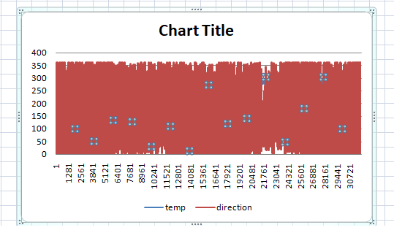

fig:wind direction vs temperature

**Approach**

As wind direction increases temperature decreases.

|  |  |  |  |
| --- | --- | --- | --- |
|  | *7Are there specific months when cities experience significant temperature*  *fluctuations?*  *What might explain these variations?*  Untitled.png  **CONCLUSION**  Here it is concluded that the monthseptember November of every year see  comparatively more fluctuation than other months of the year.   |  |  | | --- | --- | |  | *8Identify periods of extreme weather events, such as*  *storms or heatwaves, by analyzing the time-based data.*  *What patterns emerge?* | |

*9.Are there any notable differences in temperature trends between northern and southern hemisphere cities over the year? How do they relate to season*

|  |  |  |  |
| --- | --- | --- | --- |
| city | | temp | region |
| Albuquerque | | 285.6178561 | northern |
| Atlanta | | 289.7726731 | northern |
| Beersheba | | 291.5219862 | northern |
| Boston | | 283.7798228 | northern |
| Charlotte | | 288.8974827 | northern |
| Chicago | | 283.3505728 | northern |
| Dallas | | 292.3758721 | northern |
| Denver | | 282.8394066 | northern |
| Detroit | | 282.971668 | northern |
| Eilat | | 296.497276 | southern |
| Haifa | | 295.2663983 | northern |
| Houston | | 294.2042679 | southern |
| Indianapolis | | 284.7719042 | northern |
| Jacksonville | | 294.33338 | northern |
| Jerusalem | | 293.1842533 | northern |
| Kansas City | | 286.6416633 | northern |
| Las Vegas | | 292.424887 | northern |
| Los Angeles | | 290.8461161 | northern |
| Miami | | 298.1812741 | southern |
| Minneapolis | | 280.7004894 | northern |
| Montreal | | 280.3430101 | northern |
| Nahariyya | | 294.0948034 | northern |
| Nashville | | 288.5663055 | northern |
| New York | | 285.4004056 | northern |
| Philadelphia | | 285.3741682 | northern |
| Phoenix | | 295.4933578 | northern |
| Pittsburgh | | 284.0539394 | northern |
| Portland | | 284.9929292 | northern |
| Saint Louis | | 286.6759467 | northern |
| San Antonio | | 293.7856461 | southern |
| San Diego | | 290.2150442 | northern |
| San Francisco | | 288.1558205 | northern |
| Seattle | | 284.4096262 | northern |
| Tel Aviv District | | 294.512307 | northern |
| Toronto | | 281.9412408 | northern |
| Vancouver | | 283.8626537 | northern |
|  | |  |  |
| 1 | **CONCLUSION**  Here southern cities experience higher temperature than northern cities because  of the proximity of equator.  *10What are the consequences of prolonged periods of extreme cold or*  *heat in specific cities?*  *How do residents adapt to such conditions?*   |  |  | | --- | --- | | city | temp | | Average of Beersheba | 291.5219862 | | Average of Dallas | 292.3758721 | | Average of Eilat | 296.497276 | | Average of Haifa | 295.2663983 | | Average of Houston | 294.2042679 | | Average of Jacksonville | 294.33338 | | Average of Jerusalem | 293.1842533 | | Average of Las Vegas | 292.424887 | | Average of Los Angeles | 290.8461161 | | Average of Miami | 298.1812741 | | Average of Nahariyya | 294.0948034 | | Average of Phoenix | 295.4933578 | | Average of San Antonio | 293.7856461 | | Average of San Diego | 290.2150442 | | Average of Tel Aviv District | 294.512307 | | | | |

11

|  |  |  |  |  |  |  |  |  |  |  |
| --- | --- | --- | --- | --- | --- | --- | --- | --- | --- | --- |
| *Investigate whether temperature anomalies (unusual deviations from the norm)*  *coincide with certain*  *events or environmental factors in specific cities*. | | | | | | | | | | |
|  | |  | |  | |  |  |  |  |  |
|  | | example for vancouver city | | | | |  |  |  |  |
| 282.3555 | mist | |  | |
| 282.4042 | broken clouds | |  | |
| 282.4387 | sky is clear | |  | |
| 280.6588 | light rain | |  | |
| 281.1904 | few clouds | |  | |
| 280.5005 | fog | |  | |
| 280.7178 | overcast clouds | |  | |
| 282.2337 | light intensity shower rain | |  | |
| 280.7329 | moderate rain | |  | |
| 281.25 | light intensity drizzle | |  | |
| 278.8187 | scattered clouds | |  | |
| 280.5262 | proximity shower rain | |  | |
| 277.9 | heavy intensity rain | |  | |
| 279.62 | heavy snow | |  | |
| 279.69 | shower rain | |  | |

|  |  |  |  |  |  |  |  |
| --- | --- | --- | --- | --- | --- | --- | --- |
| *12* | *Analyze the impact of temperature on energy consumption patterns in cities.*  *Are there noticeable trends or correlations?* | | | | | |  |
|  |  |  |  |  |  |  |  |
|  |  |  |  |  |  |  |  |
|  |  | As the temperature increases the energy consumption pattern increases. | | |  |  |  |
|  |  |  |  |  |  |  |  |
|  |  |  |  |  |  |  |  |
| 13 |  |  |  |  |  |  |  |
| *How do specific wind patterns impact air quality and pollution dispersion in urban areas?*  *Analyze wind direction data for insights*. | | | | | | |  |
|  |  |  |  |  |  |  |  |
|  |  |  |  |  |  |  |  |
|  |  | As the wind direction and speed increases the pollution and dispersion also increases. | | | |  |  |
|  |  |  |  |  |  |  |  |
|  |  |  |  |  |  |  |  |
| 14 | *Identify cities prone to strong winds and the potential consequences,*  *such as increased risk of natural disasters or challenges for*  *transportation*. | | | | | | |
| city | windspeed | | | | | | |
| Average of Boston | 3.380889242 | | | | | | |
| Average of Chicago | 3.759325555 | | | | | | |
| Average of Dallas | 3.631919737 | | | | | | |
| Average of Detroit | 3.16503138 | | | | | | |
| Average of Eilat | 3.452576415 | | | | | | |
| Average of Haifa | 3.299406181 | | | | | | |
| Average of Indianapolis | 3.225360205 | | | | | | |
| Average of Kansas City | 3.430765491 | | | | | | |
| Average of Miami | 3.23649287 | | | | | | |
| Average of Minneapolis | 3.382232044 | | | | | | |
| Average of Montreal | 3.831896933 | | | | | | |
| Average of Nahariyya | 3.024292044 | | | | | | |
| Average of New York | 3.210953666 | | | | | | |
| Average of Saint Louis | 3.048196765 | | | | | | |
| Average of San Antonio | 3.022208963 | | | | | | |
| Average of Toronto | 3.830769911 | | | | | | |

Here strong wind refers to where speed is more than 3.

|  |  |  |  |  |  |  |  |  |  |  |  |  |  |  |  |  |  |  |  |  |  |  |  |  |  |  |  |  |  |  |  |  |  |  |  |  |  |  |  |  |  |  |  |  |  |  |  |  |  |
| --- | --- | --- | --- | --- | --- | --- | --- | --- | --- | --- | --- | --- | --- | --- | --- | --- | --- | --- | --- | --- | --- | --- | --- | --- | --- | --- | --- | --- | --- | --- | --- | --- | --- | --- | --- | --- | --- | --- | --- | --- | --- | --- | --- | --- | --- | --- | --- | --- | --- |
| 15 | *15.Explore whether wind speed and direction influence the*  *frequency and severity of weather-related events (e.g., hurricanes,*  *storms) in coastal cities*.   |  |  |  | | --- | --- | --- | | weather | avg(direction) | avg(speed) | |  | 0 | 0 | | few clouds | 224.3202331 | 1.728813559 | | sky is clear | 205.1565038 | 2.208219178 | | overcast clouds | 207.6721541 | 2.197674419 | | broken clouds | 231.8870044 | 2.573333333 | | scattered clouds | 221.3987247 | 1.818181818 | | light rain | 243.1685924 | 1.941666667 | | light intensity shower rain | 188.7115385 | 2.769230769 | | heavy intensity rain | 213.8845925 | 3.047619048 | | moderate rain | 221.8358355 | 2.581818182 | | mist | 205.0531915 | 1.808510638 | | fog | 225.9295833 | 2.208333333 | | proximity shower rain | 216.3775 | 1.5 | | thunderstorm with heavy rain | 287.15 | 0 | | very heavy rain | 284.039 | 2.5 | |

**POWERBI**

*1.Can you create a geographical map in Power BI showing the distribution of cities in the dataset based on their latitude and longitude?*

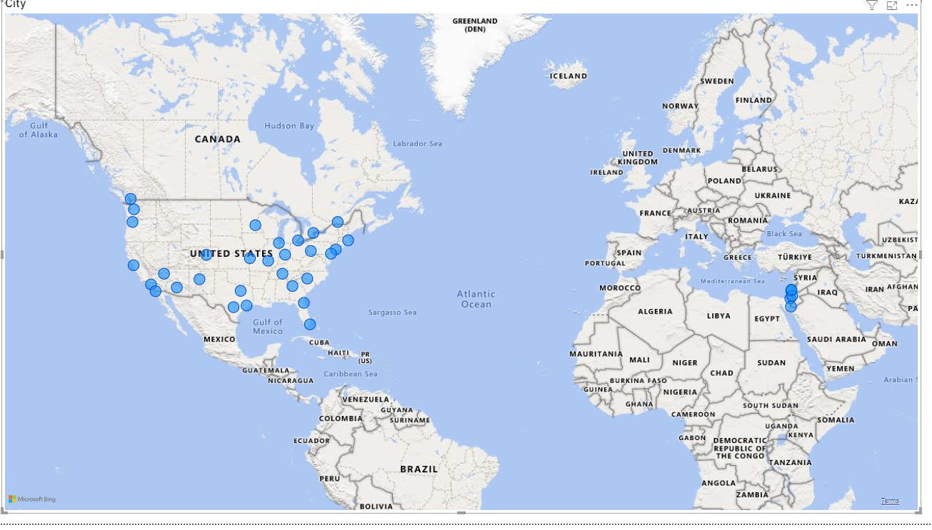

*2.In Power BI, can you create a bar chart representing the top 10 countries with the highest number of cities in the dataset?*

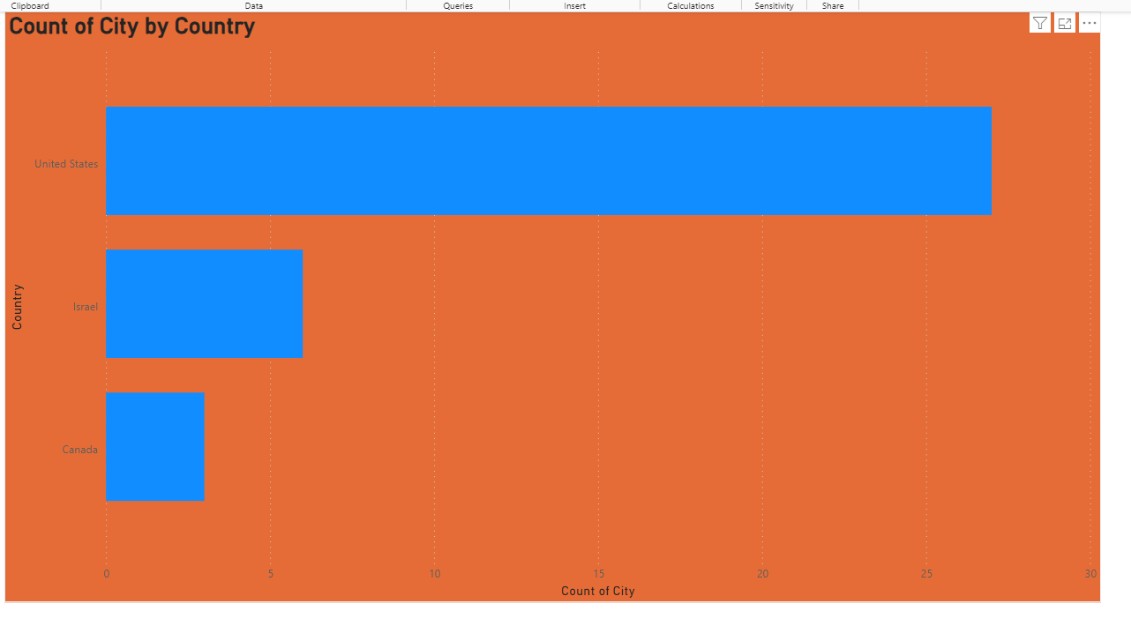

*3.How does the distribution of cities in terms of latitude vary across different continents? Create a scatter plot in Power BI to illustrate this*.

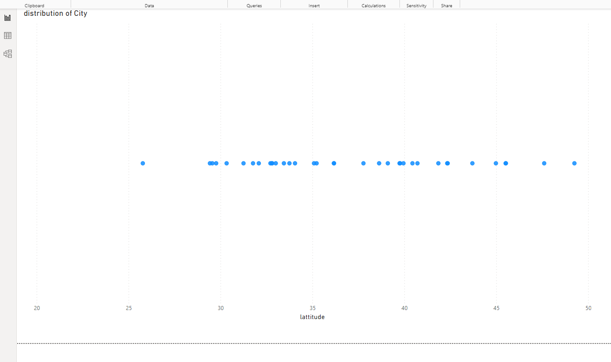

*4.Create a line chart in Power BI to display the temperature trends over time for a selected city. Highlight extreme temperature events*.

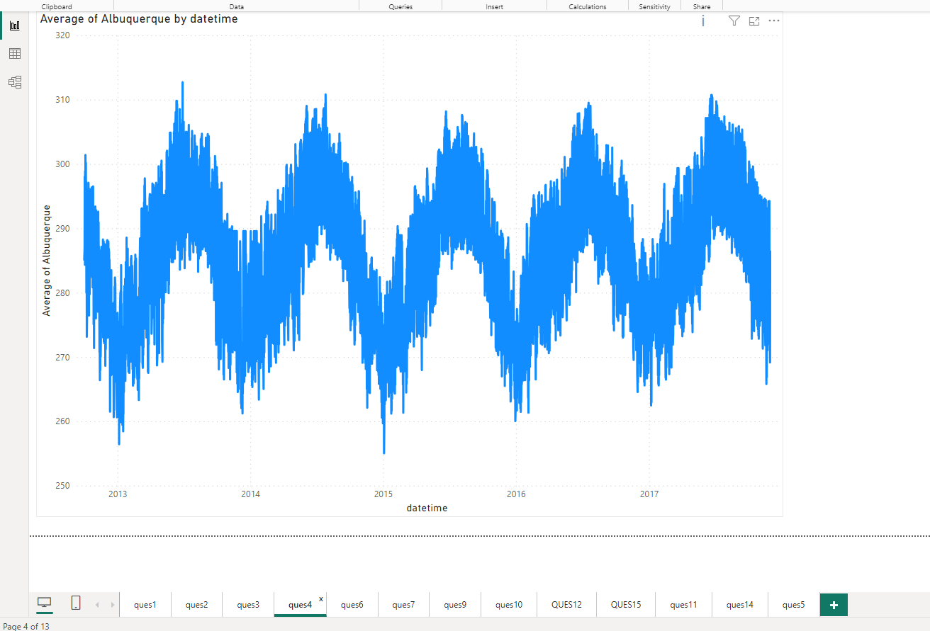

*5How does humidity vary across different cities? Generate a heatmap in Power BI to visualize this variation.*

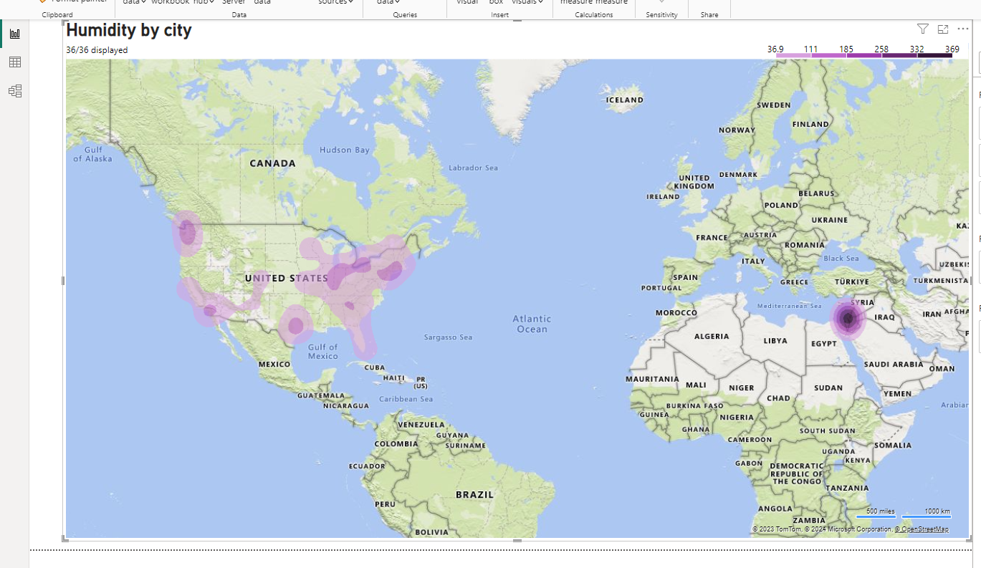

*6Can you create a time-series chart in Power BI showing the relationship between wind speed and air pressure for a specific city?*

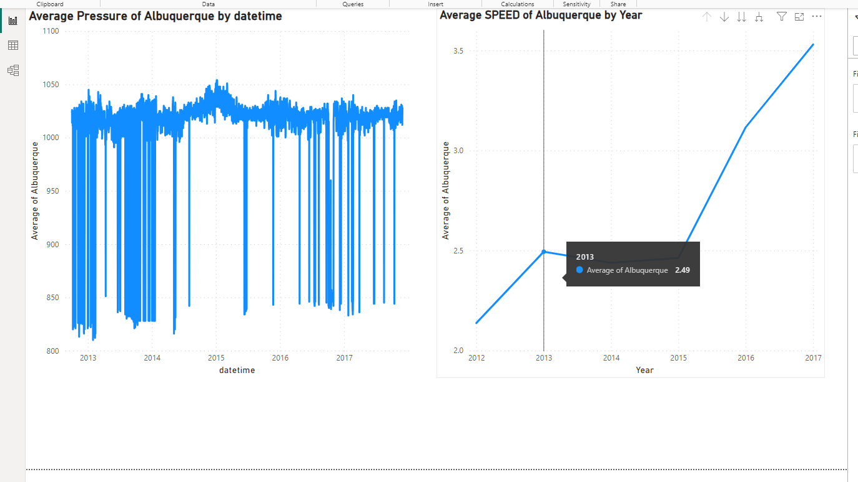

*7Create a time-series line chart in Power BI to show the overall temperature trends over the entire dataset*.

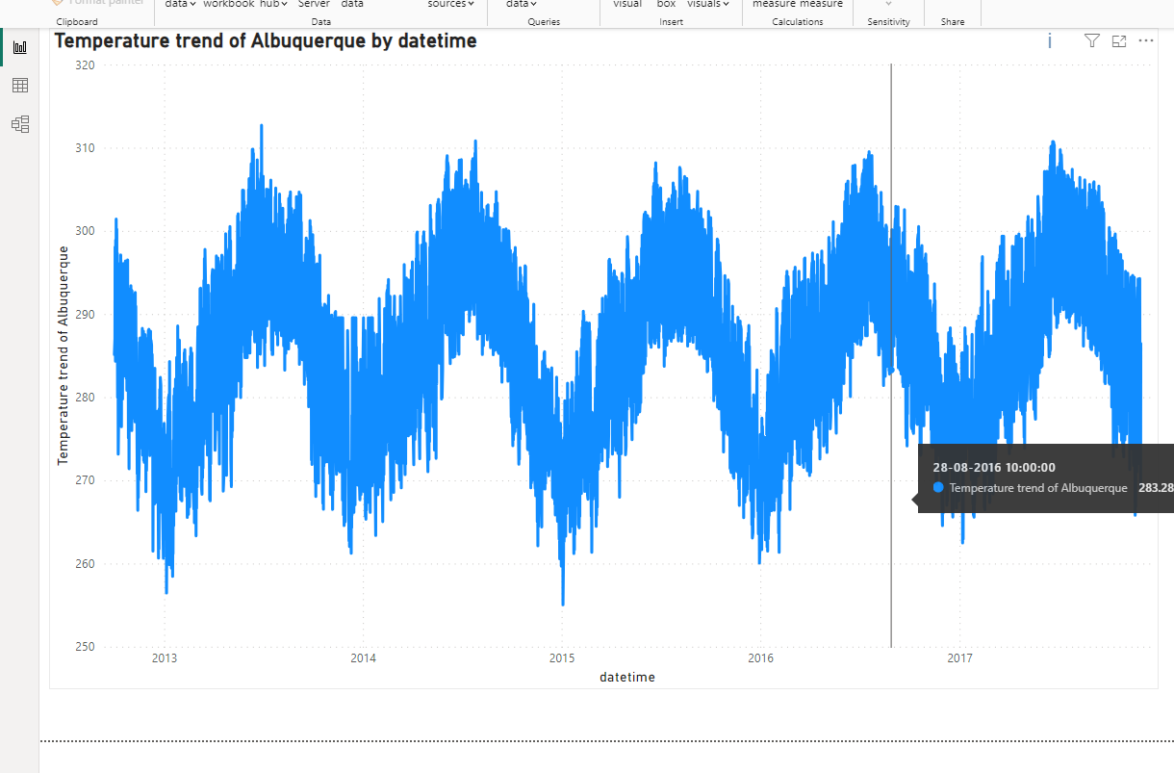

*9.How does the wind speed change over the course of a day? Create a radial chart in Power BI to represent this*

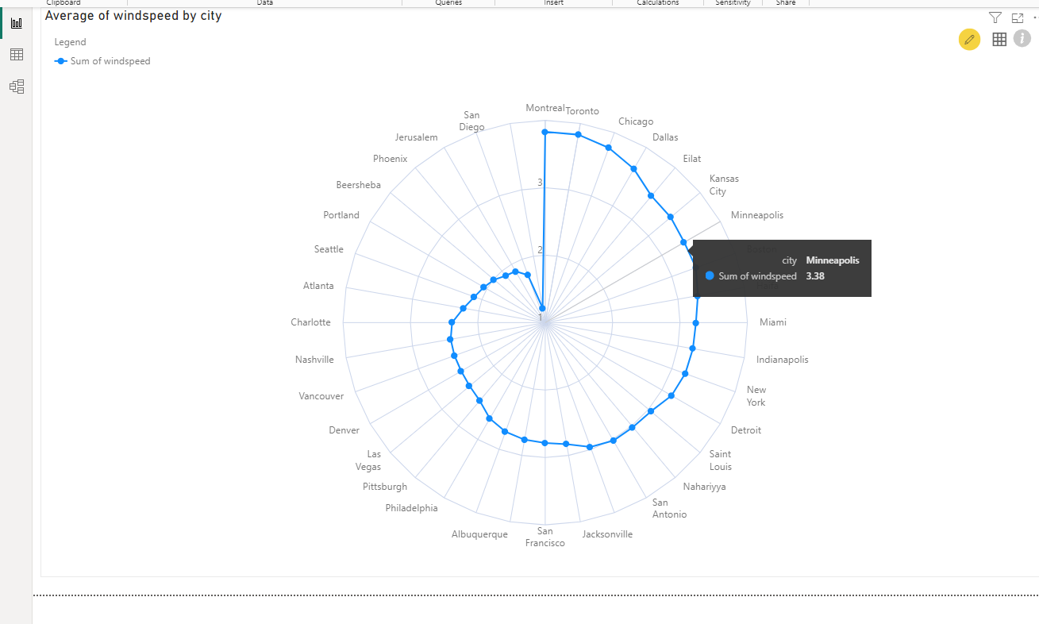.

*10Create a Power BI chart comparing the temperature variations between two selected cities over a specific timeframe*.

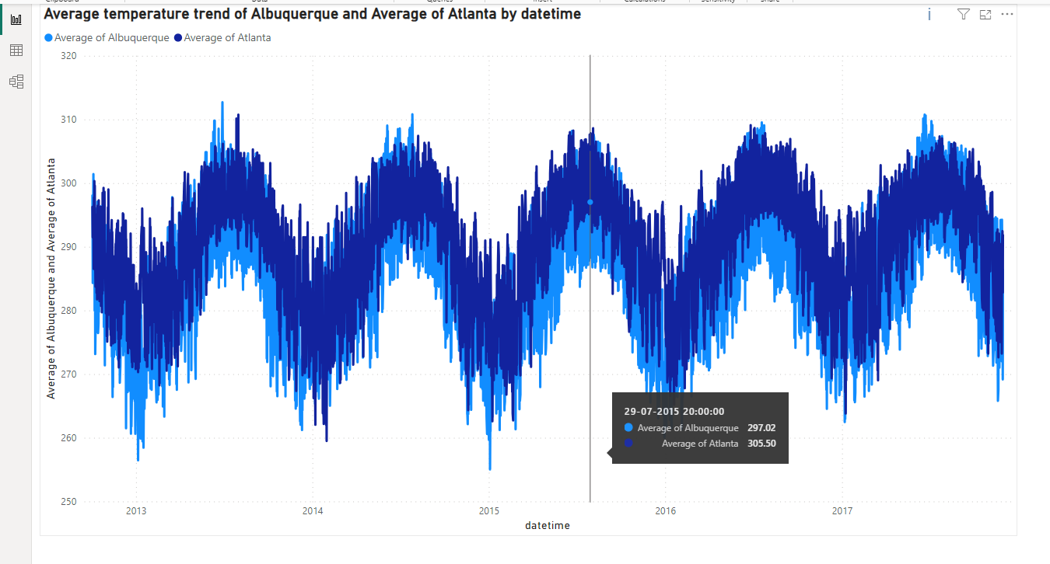

*11Can you build a heatmap in Power BI to show the temperature ranges for cities across different countries*?

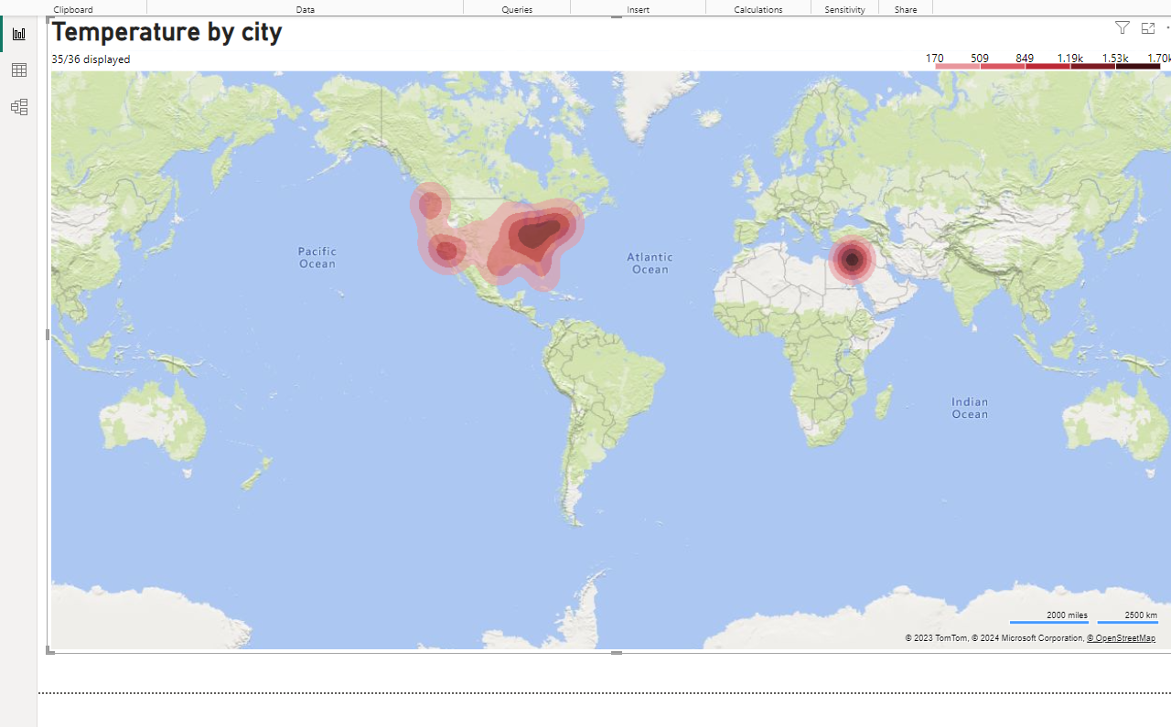

*12.Create a bar chart in Power BI to highlight cities with the highest and lowest average temperatures in the dataset*.

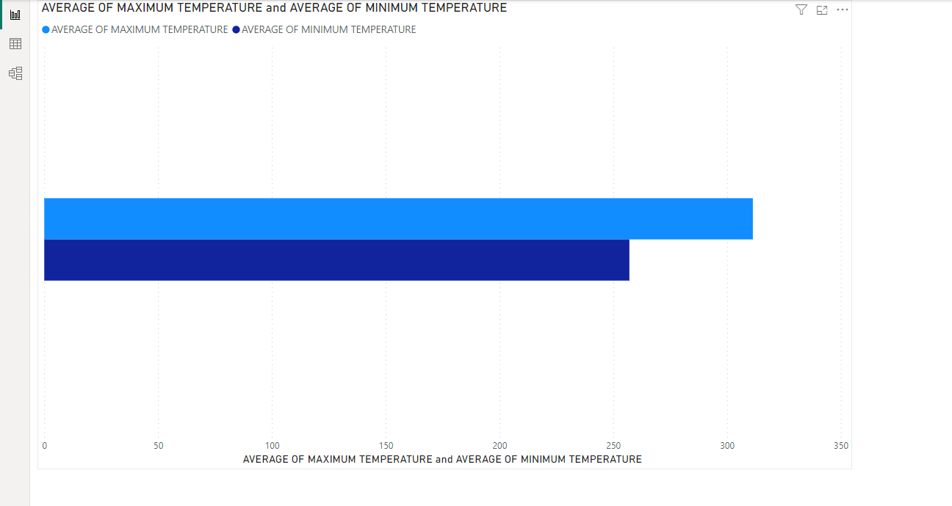

*14.Can you generate a Power BI heatmap illustrating the average wind speeds across cities for different months of the year?*

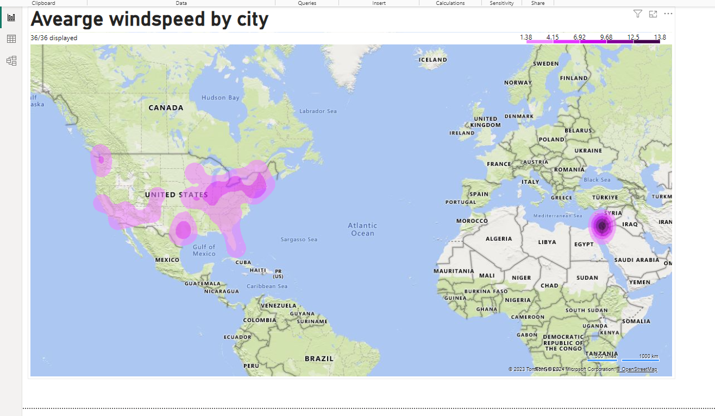

*15Create a Power BI scatter plot to show the relationship between wind speed and air pressure for a specific city.*

